**Abstract**

According to records/research there is a huge growth in papulation from last decade, and the occurrence of road accidents also increased. As per the one research around half million accidents occur in a year alone, in India alone. In detailed, around 60% (Liu) of these accidents are happened due to driver drowsiness. Drowsiness affects the driving ability in the following areas (a)It impairs coordination (b)It causes longer reaction times and (c)It impairs judgment

In this project, trying to provide a real time monitoring system using image processing, face/eye detection techniques. Further, to ensure real-time computation, Haarcascade samples are used to differentiate between an eye blink and drowsy/fatigue detection.

*Key Words*

Face detection, Eye Detection, Haarcascade, Drowsy driver detection, Image Processing

*Introduction:*

According to research, driver drowsiness results in over 60% of the road accidents each year. Utilizing innovation technologies to detect driver drowsiness is a fascinating challenge that would help in preventing accidents.

In the past, different efforts have been reported in the writing on approaches for drowsiness detection of car driver. In the most recent decade alone, many countries have started to consider the vehicle driver security issue. Scientists have been taking a shot at the recognition of vehicle driver's laziness utilizing different systems, for example, physiological discovery and Road checking strategies. Physiological recognition strategies exploit the way that rest mood of an individual is unequivocally related with mind and heart exercises. Be that as it may, all the examination till date in this methodology need cathode contacts on the car drivers' head, face, or chest making it non-implementable in certifiable situations. Street observing (Bhatt) is one of the most generally utilized method, frameworks dependent on this methodology, incorporate Attention help by Mercedes, Fatigue Detection System by Volkswagon, Driver Alert by Ford, Driver Alert Control by Volvo. All the referenced methods screen the street and driver conduct attributes to distinguish the languor of the vehicle driver. Barely any parameters utilized incorporate whether the driver is adhering to the path rules, fitting utilization of the pointers and so forth, if there are variations in these parameters, over the resilience level then the framework infers that the driver is sleepy. This methodology is naturally imperfect as observing the street to distinguish laziness is a greater amount of a backhanded methodology and furthermore needs exactness.

In this project I propose a direct approach that make use of vision-based techniques to detect drowsiness.

The major/main challenges in this proposed technique included

1. Developing real time system
2. Face Detection
3. Iris detection under various conditions like driver position, with/without glasses, lighting etc
4. Blink detection

The focus on developing/designing a real time system that will be accurately monitor the state of driver’s eye(close/open). By monitoring driver’s face especially eyes, it is trusted that the symptoms of driver drowsiness can be detected early enough to avoid a car accident. Detection of drowsiness include the identification of eye movements and blink patterns from live video.

***1.LITERATURE REVIEW***

As the goal of this literature review is to inform the choice of algorithms for comparison to algorithms, the following sections focus on presenting typical examples of the various approaches that have been attempted. For the purposes of this review, approaches are described in terms of a broad grouping of algorithms that seek to identify similar signatures of drowsiness. The approaches discussed in this review include driver-based, vehicle-based, and combination algorithms.

***1.1Face and Eye detection by Cellular Neural Network algorithms:***

In this project, a novel approach (Roska) to deal with basic pieces of face detection problems is given, based on analogic cellular neural network (CNN) algorithms. The proposed CNN algorithms discover and normalize human faces effectively while cause for most accidents related to vehicle crashes. Driver drowsiness their time necessity is a small amount of the previously used methods. The algorithm begins with the detection of heads on color pictures utilizing deviations in deviations and structure of the human face and that of the background. By normalizing the distance and position of the reference points, all faces should be transformed into a similar size and position. For normalization, eyes fill in as perspectives.

***1.2Face Detection using Haar Cascades:***

Object Detection utilizing Haar feature-based cascade classifiers is an effective object detection method proposed by Paul Viola and Michael Jones in their paper, "Rapid Object detection utilizing a Boosted Cascade of Simple Features" in 2001. It is a machine learning-based methodology where a cascade function is trained from a lot of positive and negative pictures. It is then used to detect objects in different pictures. Here we will work with face detection. At first, the algorithm needs a lot of positive (image of faces) and negative images (images without faces) to prepare the classifier. At that point, we must extract features from it. For this, Haar features that appeared in the images are used. They are just like our convolutional kernel. Each feature is solitary esteem got by subtracting the total of pixels under the white square shape from an aggregate of pixels under the dark square shape.

***1.3Algorithm for Eye Detection on Grey Intensity Face***

This project presents a strong eye detection algorithm for grey intensity images. The possibility of my strategy is to consolidate the individual points of interest of two existing systems, feature-based methods and format-based methods, and to overcome their inadequacies. Right off the bat, after the area of the face locale is detected, a component-based technique will be utilized to distinguish two harsh districts of the two eyes on the face. At that point, a precise recognition of iris focuses will be proceeded by applying a layout-based strategy in these two unpleasant districts. Results of experiments to the faces without spectacles show that the proposed approach is not only robust but also quite efficient.

***2.System Design/Architecture***

The system architecture of the proposed system is represented in below fig,

System Architecture

**Camera**

**Dividing into frames**

**Face detection**

**Haarcascade for face detection**

**Alarm**

**Drowsiness Detection**

**Eye Detection**

Here presenting the different important blocks in proposed system and their high-level interaction. It can see that the system consists of 5 distinct modules namely, (a)Video acquisition, (b) Dividing into frames, (c)Face Detection, (d) Eye Detection and (e) Drowsiness Detection. In addition to these there are two external hardware’s like camera and audio alarm.

***2.1Video acquisition***: Video acquisition mainly involves obtaining the live video feed of the automobile driver. Video acquisition is achieved, by making use of a camera.

***2.2Dividing into frames***: This module is used to take live video as its input and convert it into a series of frames/ images, which are then processed.

***2.3Face detection:*** The face detection function takes one frame at a time from the frames provided by the frame grabber, and in each frame, it tries to detect the face of the automobile driver. This is achieved by making use of a set of pre-defined Haarcascade samples.

***2.4Eyes detection:*** Once the face detection function has detected the face of the automobile driver, the eyes detection function tries to detect the automobile driver's eyes. This is achieved by making use of a set of pre-defined Haarcascade samples.

***2.5Drowsiness detection:*** After detecting the eyes of the automobile driver, the drowsiness detection function detects if the automobile driver is drowsy or not, by taking into consideration the state of the eyes, that is, open or closed and the blink rate

As the proposed system utilizes OpenCV libraries, there is no necessary minimum resolution requirement on the camera. The schematic portrayal of the algorithm of the proposed system is depicted in below fig. In the proposed algorithm, the first video obtaining is accomplished by utilizing an outside camera set before the vehicle driver. The gained video is then changed over into a progression of casings/pictures. The subsequent stage is to recognize the car driver's face, in every single casing extricated from the video

As indicated in below Figure, we start with discussing face detection which has 2 important functions (a) Identifying the region of interest, and (b) Detection of face from the above region using Haarcascade. To avoid processing the entire image, we mark the region of interest. By considering the region of interest, it is possible to reduce the amount of processing required and speeds up the processing, which is the primary goal of the proposed system

For deducting the face, since the camera is centered around the car driver, we can abstain from handling the picture at the corners hence diminishing a lot of preparing required. When the locale of intrigue is characterized face has been recognized, the area of intrigue is presently the face, as the following stage includes identifying eyes. To recognize the eyes, rather than handling the whole face area, we mark a locale of enthusiasm inside the face district which further aides in accomplishing the essential objective of the proposed framework. Next, we utilize Haarcascade XML record built for eye location and recognize the eyes by handling just the district of intrigue. When the eyes have been recognized, the subsequent stage is to decide if the eyes are in open/shut state, which is accomplished by removing and inspecting the pixel esteems from the eye district. If the eyes are identified to be open, no move is made. Yet, in the event that eyes are identified to be shut consistently for two seconds agreeing to, that is a specific number of casings relying upon the casing rate, at that point, it implies that the vehicle driver is feeling tired and a sound alert is activated. Be that as it may, if the shut conditions of the eyes are not constant, at that point it is pronounced as a flicker***.***

*High Level System Flow*

Video acquisition

K=0

Blink

Drowsy

IF K>6

K=K+1

Eyes open

Determining open/closed state of eye

Detect Eye from ROI

Set the image ROI to a fixed area inside face

Is No. of faces>0

Face detected for individual frames

Dividing into frames

3.**Implementation**

The implementation details of each the modules can be explained as follows:

**3.1 Video Acquisition**

OpenCV gives broad help to securing and preparing live recordings. It is additionally conceivable to pick whether the video must be caught from the in-constructed webcam or an outer camera by setting the correct parameters. As referenced before, OpenCV doesn't determine any base necessity on the camera, anyway OpenCV as a matter, of course, expects specific goals of the video that is being recorded, if the goals don't coordinate, at that point a blunder is tossed. This blunder can be countered, by superseding the default esteem, which can be accomplished, by physically indicating the goals of the video being recorded.

**3.2 Dividing into frames**

When the video has been gained, the subsequent stage is to isolate it into a progression of edges/pictures. This was at first done as a 2-stage process. The initial step is to snatch an edge from the camera or a video document, for our situation since the video isn't put away, the edge is gotten from the camera and once this is accomplished, the following stage is to recover the gotten edge. While recovering, the picture/outline is first decompressed and afterward recovered. In any case, the two-stage process took a great deal of handling time as the snatched casing must be put away briefly. To conquer this issue, we thought of a solitary advance procedure, where a solitary capacity snatches a casing and returns it by decompressing.

**3.3 Face detection**

When the casings are effectively extricated the subsequent stage is to recognize the face in every one of these edges. This is accomplished by utilizing the Haarcascade record for face identification. The Haarcascade document contains various highlights of the face, for example, stature, width and limits of face hues., it is developed by utilizing various positive and negative examples. For face location, we first burden the course record. At that point pass the gained edge to an edge discovery work, which distinguishes all the potential objects of various sizes in the casing. To diminish the measure of preparing, rather than distinguishing objects of every single imaginable size, since the substance of the car driver involves a huge piece of the picture, we can determine the edge identifier to identify just objects of a specific size, this size is chosen dependent on the Haarcascade record, wherein each Haarcascade document will be intended for a specific size. Presently, the yield the edge locator is put away in a cluster. Presently, the yield of the edge indicator is then contrasted with the course record with recognize the face in the casing. Since the course comprises of both positive and negative examples, it is required to determine the quantity of disappointments on which an item identified ought to be named a negative example. In our framework, we set this incentive to 3, which helped in accomplishing both exactness just as less handling time. The yield of this module is an edge with face recognized in it.

**3.4 Eye detection**

Subsequent to distinguishing the face, the following stage is to identify the eyes, this can be accomplished by utilizing a similar method utilized for face discovery. Notwithstanding, to lessen the measure of preparing, we mark the locale of enthusiasm before attempting to distinguish the eyes. The area of intrigue is set by considering the following:

* The eyes are available just in the upper piece of the face distinguished.
* The eyes are available a couple of pixels lower from the top edge of the face.

When the locale of intrigue is denoted, the edge recognition procedure is applied uniquely on the district of intrigue, in this way lessening the measure of handling fundamentally. Presently, we utilize a similar procedure as face identification for identifying the eyes by utilizing Haarcascade Xml record for eyes discovery. However, the yield got was not exceptionally effective, there were multiple articles named positive examples, showing multiple eyes. To beat this issue, the accompanying advances are taken:

* Out of the distinguished items, the article which has the most elevated surface region is gotten. This is considered as the main positive example.
* Out of the rest of the articles, the item with the most elevated surface zone is resolved. This is considered as the subsequent positive example.
* A check is made to ensure that the two positive examples are not the equivalent.
* Now, we check if the two positive examples have at least 30 pixels from both edges.
* Next, we check if the two positive examples have at least 20 pixels separated from one another.

Subsequent to breezing through the above assessments, we reason that the two articles i.e positive example 1 and positive example 2, are the eyes of the car driver

**3.5 Drowsiness detection**

When the eyes are recognized, the subsequent stage is to decide whether the eyes are in shut or open state. This is accomplished by separating the pixel esteems from the eye district. In the wake of removing , we check in the event that these pixel esteems are white, on the off chance that they are white, at that point it derives that the eyes are in the open state, in the event that the pixel esteems are not white, at that point it construes that the eyes are in the shut state. This is accomplished for every single edge removed. On the off chance that the eyes are recognized to be shut for two seconds or a specific number of sequential casings relying upon the edge rate, at that point the vehicle driver is distinguished to be languid. On the off chance that the eyes are identified to be shut in non-back to back edges, at that point We proclaim it as a flicker. On the off chance that sleepiness is recognized, an instant message is shown alongside setting off a sound alert. However, it was seen that the framework was not ready to run for an all-encompassing timeframe, because the change of the gained video from RGB to grayscale was involving an excess of memory. To conquer this issue, rather than changing over the video to grayscale, the RGB video just was utilized for handling. This change brought about the accompanying focal points,

* Better separation between hues, as it utilizes multichannel hues.
* Consumes less memory.
* Capable of accomplishing flicker recognition, in any event, when the car driver is wearing displays

**4.CONCLUSION**

The essential objective of this project is to build up a continuous laziness observing framework in vehicles. We built up a straightforward framework comprising of 5 modules namely(a) video procurement, (b) isolating into outlines, (c) face identification, (d) eye location, and (e)drowsiness recognition. Every one of these parts can be executed autonomously in this way giving an approach to structure them dependent on the necessities.

Four features that make our system different from existing ones are:

a) Focus on the driver, which is a direct way of detecting the drowsiness

(b) A real-time system that detects face,iris, blink, and driver drowsiness

(c) A completely non-intrusive system, and (d) Cost effective

**5.1 Limitations**

The following are some of the limitations of the proposed system.

• The system fails, if the automobile driver is wearing any kind of sunglasses.

• The system does not function if there is light falling directly on the camera

**5.2 Future Enhancement**

The system at this stage is a “Proof of Concept” for a much substantial endeavor. This will serve as a first step towards a distinguished technology that can bring about an evolution aimed at ace development. The developed system has special emphasis on real-time monitoring with flexibility, adaptability and enhancements as the foremost requirements.

Future enhancements are always meant to be items that require more planning, budget and staffing to have them implemented. There following are couple of recommended areas for future enhancements:

• **Standalone product**: It can be implemented as a standalone product, which can be installed in an automobile for monitoring the automobile driver.

• **Smart phone application**: It can be implemented as a smart phone application, which can be installed on smart phones. And the automobile driver can start the application after placing it at a position where the camera is focused on the driver.

**REFERENCES**:

[1] Ruian Liu, et.a;, "Design of face detection and tracking system," Image and Signal Processing (CISP), 2010 3rd International Congress on , vol.4, no., pp.1840,1844, 16-18 Oct. 2010

[2] Xianghua Fan, et.al, "The system of face detection based on OpenCV," Control and Decision Conference (CCDC), 2012 24th Chinese, vol., no., pp.648,651, 23-25 May 2012

[3] Goel, P, et.al., "Hybrid Approach of Haar Cascade Classifiers and Geometrical Properties of Facial Features Applied to Illumination Invariant Gender Classification System," Computing Sciences (ICCS), 2012 International Conference on, vol., no., pp.132,136, 14-15 Sept. 2012

[4] Parris, J., et.al, "Face and eye detection on hard datasets," Biometrics (IJCB), 2011 International Joint Conference on, vol., no., pp.1,10, 11-13 Oct. 2011

[5] Peng Wang., et. a; "Automatic Eye Detection and Its Validation," Computer Vision and Pattern Recognition - Workshops, 2005. CVPR Workshops. IEEE Computer Society Conference on, vol., no., pp.164,164, 25-25 June 2005

[6] Picot, A. et.al., “On-Line Detection of Drowsiness Using Brain and Visual Information," Systems, Man and Cybernetics, Part A: Systems and Humans, IEEE Transactions on, vol.42, no.3, pp.764,775, May 2012

[7] Xia Liu; Fengliang Xu; Fujimura, K., "Real-time eye detection and tracking for driver observation under various light conditions," Intelligent Vehicle Symposium, 2002. IEEE, vol.2, no., pp.344,351 vol.2, 17-21 June 2002

Python Code:

Testing

**Male eyes and face recognition**

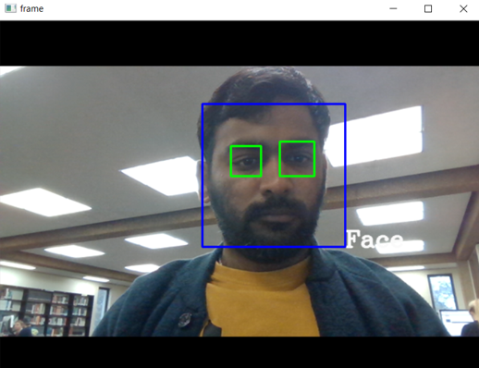

**Female eyes and face recognition**

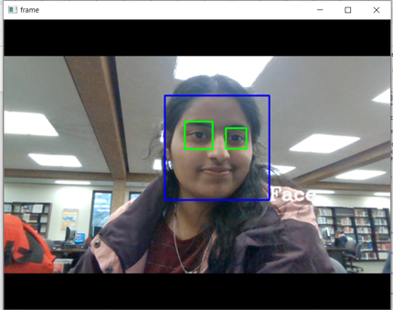

**Female eyes with glasses and face recognition**

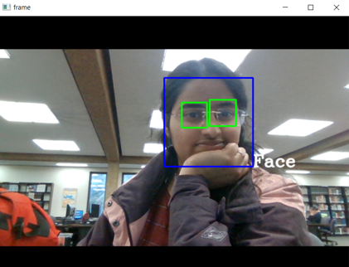

**Male & female eyes and face recognition in one frame**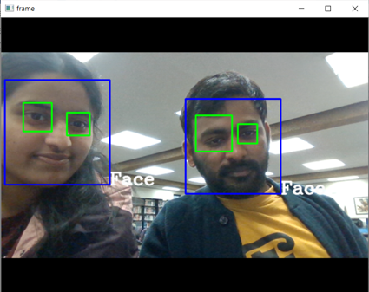

**Two Male eyes and face recognition in one frame**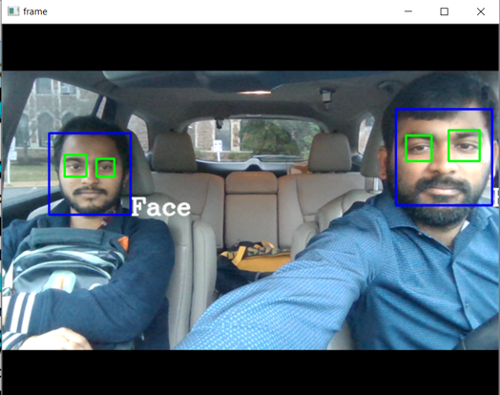

**Two Male eyes with glasses and face recognition in one frame**

